PROJECT PROPOSAL

Electronic Examination Marking (e-marker)

Submitted By

Amal Hamood Al-jabri : 16j1023
Maryam Said Al-Hashmi : 110S091
Salwa Harib Al-Tobi : 16j09546

Level: Bachelor Specialization: Software Engineering

Name & Signature of Project Supervisor: ____________________________________________

Date of Submission : __________________
__________________________________________________________________________
Approved By

Proposal Review Panel

1. ____________________________________________________________________
Name Signature Date
□Accepted □Rejected □Pending
Comments (if any):

2.____________________________________________________________________
Name Signature Date
□Accepted □Rejected □Pending
Comments (if any):

Electronic Examination Marking (e-marker)

1.Problem Statement
As the days pass, new technologies have been created to make life easy. In education environment, the teachers face some difficulties to correct some questions like multiple choices and true /false questions. So they have to go through the questions several times to make sure of their correction, as long as they will correct each paper manually. That will take a lot of their time to finish one student paper.
2. Project Objective
New generation creates new things. People nowadays prefer using electronic devices due to the ease of use and time consuming. Electronic Examination Marking (e-marker) will save lecturers effort and time on marking student's examination sheets.

3. Project Description
3.1 General Framework:
E-marker is developed for marking exam sheets by scanning the Answer sheet and the result sheet. E-marker will allow the user to import the two scanned images and will compare them according to the shaded options then will calculate the total marks. In case of references all the students detail will be stored in the database.

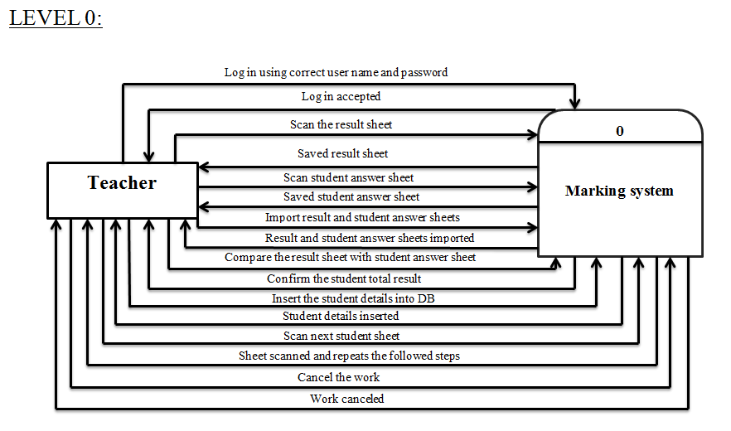

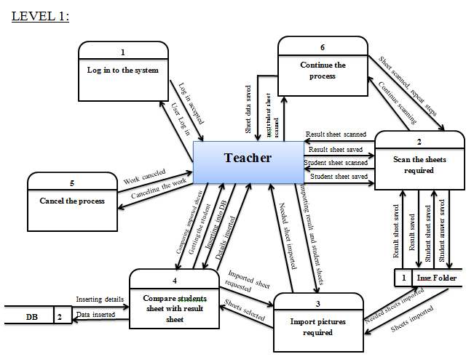
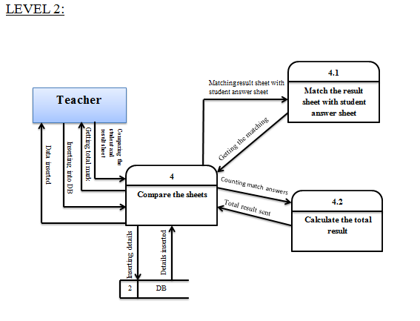

3.2 Module Description
a. Login module: the user will have to add username and password to start
using the application for security purpose.
b. Scanning module: the scan result button will allow the user to scan the correct
answer sheet, and the scan student result sheet button will scan the student sheet.
User will save the scanned images into a folder.
c. Importing module: user will be allowed to import the two scanned images from
the folder and once the next button is clicked it will compare the images and calculate
the total mark. User can insert the total mark into the database.
d. Conformation module: displaying the total mark of the student with his/her details
which will be retrieved from the database.

4. Requirements of the proposed system

4.1 Hardware requirement:
- 1GB RAM to handle java tools.
-32bit or 64 bit
- CPU: 400MHZ or more.
- Scanner and PC.

4.2 User Requirement:
- Flexible images scan.
- Comparison of two images.
-calculate the total mark according to the shaded options.
- Scan multiple images.
- Safety and protection.
- Convenient user interface.
- Present Student details.

4.3 Software Requirements
- Netbeans
- Eclipse

5. Prototype of result sheet and answer sheet of the exam.
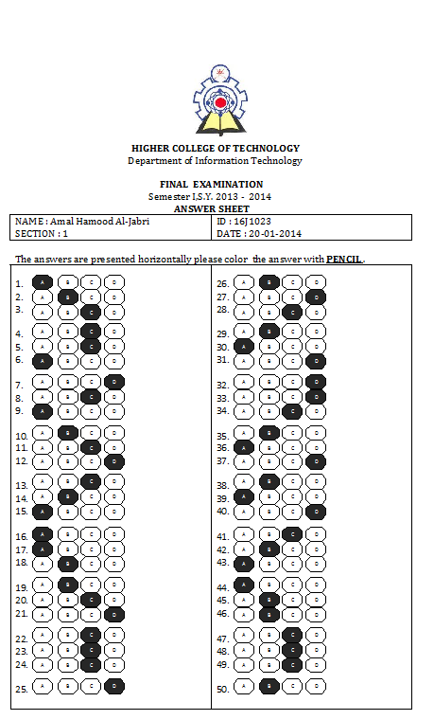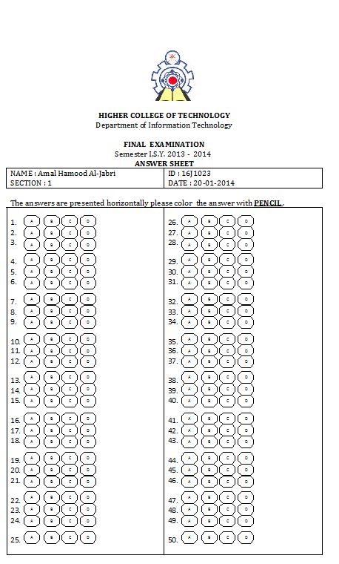
“Exam Result Sheet “ “Student Answer Sheet”

6.Action Plan

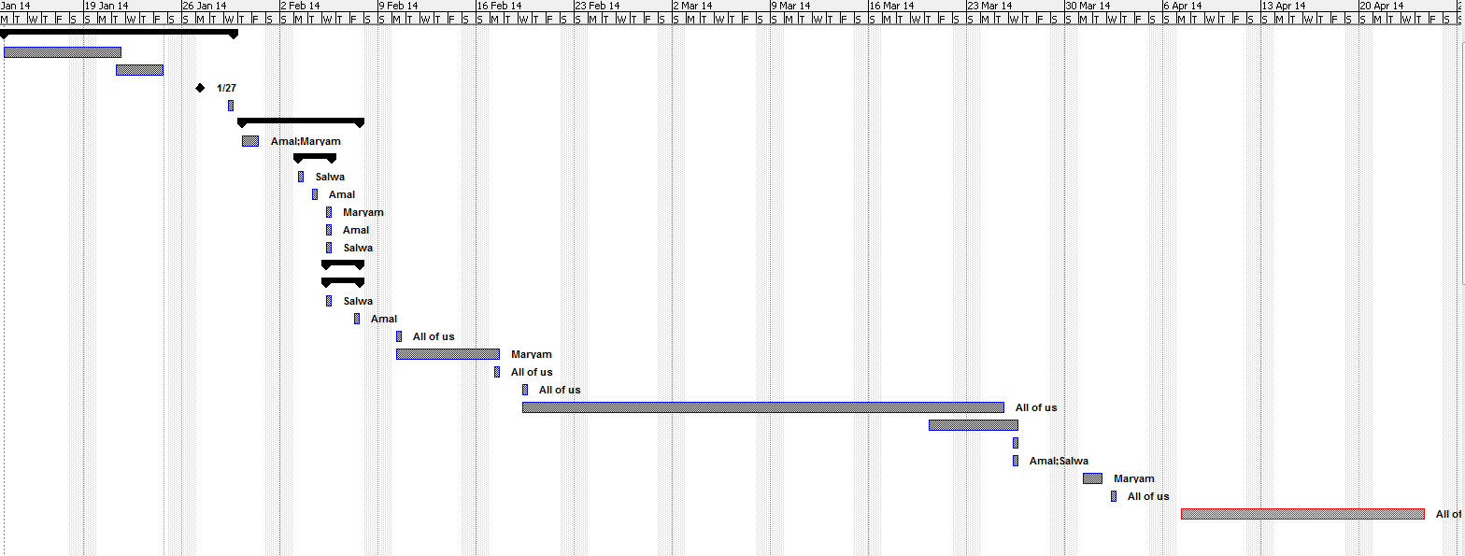

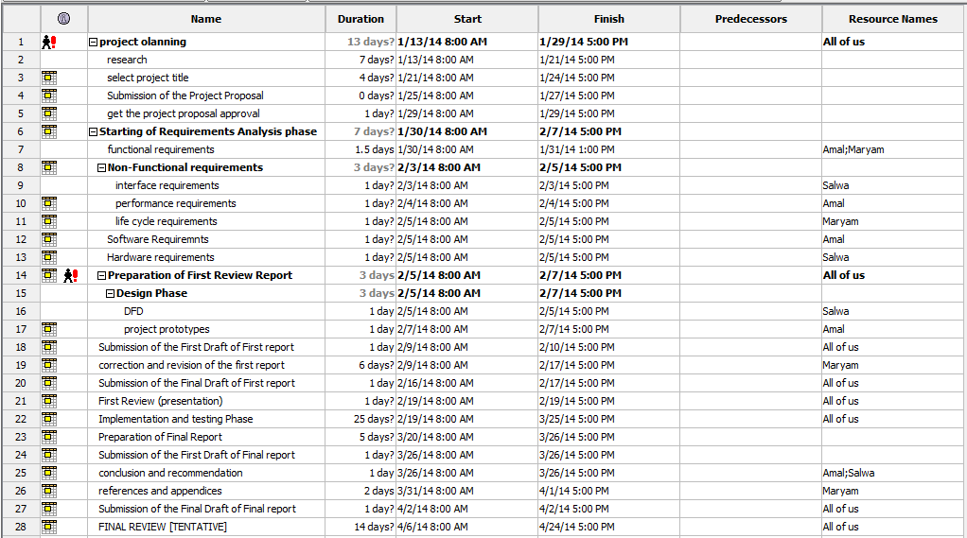

7. References
- Kathy Sierra and Bert Bates, Head First Java, O'Reilly Media, USA, February 2005
- Eric Freeman, head First Design Patterns, O’Reilly Media, USA, Nov 2004
- http://www.javaworld.com/jw-04-1996/jw-04-threads.html

